B39SB Time and Frequency Signal Analysis: Elements of Communication Systems

Tutorial 2 – Brief Solutions

________________________________________________________________________________
Modulation theorem: if , then
Double-Sideband (DSB) Modulation: .
Phase Modulation (PM):
Frequency Modulation (FM):
________________________________________________________________________________

P1. A single-tone audio signal 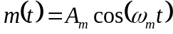 is modulated by a high-frequency carrier wave 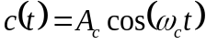, where 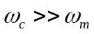. Obtain and sketch the spectrum of the resulting DSB modulated signal.

Solution.
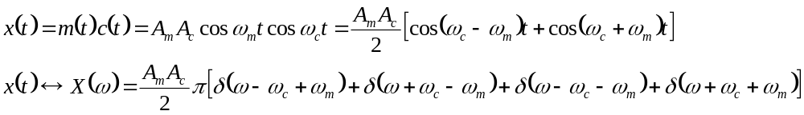
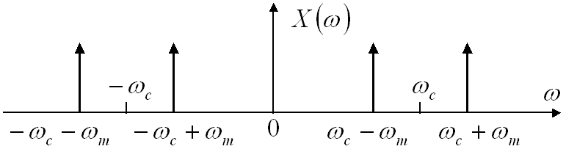

P2. Let be a real-valued signal with when . Amplitude modulation is performed to produce the signal . A proposed demodulation technique consists of multiplying the modulated signal by and passing through a lowpass filter with the cutoff frequency and passband gain of 2. Determine .

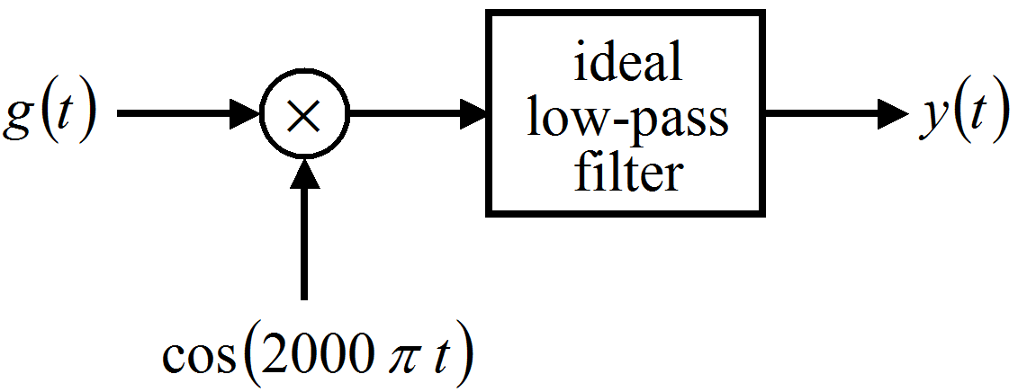

Solution.
Applying the modulation theorem shows that a low-pass filter with the cut-off frequency kills this signal. Thus .

P3. Suppose and . If the product is passed through an ideal lowpass filter with cutoff frequency and passband gain of 2, determine the signal obtained at the output of the lowpass filter.

Solution.
Now it is clear that is removed by the low-pass filter (apply the modulation theorem).
Consider the remaining part .

The lowpass filter with passband gain 2 reconstructs the first sinusoid: . The second sinusoid is reconstructed if we assume that the filter preserves the frequency (the problem is not properly stated, as it is not clear how the filter affects the frequency).

P4. A conventional AM signal is of the form , 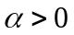. Show that, to avoid distortions (if an envelope detector is used), 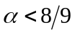.

Solution.

To avoid distortion, the envelope of 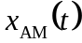 should be positive. That is

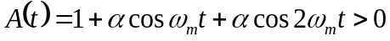 or, in other words, 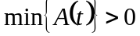.

We can find the minimum value of 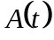 by computing its derivative:

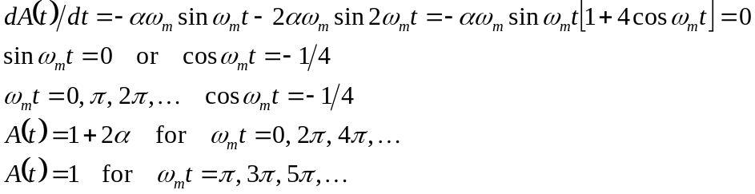

For 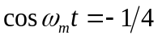we have 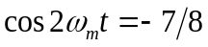, 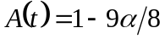.

Since , the minimum value of is 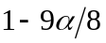. Hence 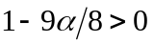 which yields .

P5. An interesting signal having a linearly varying frequency is the chirp signal. It is expressed in the general form as 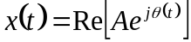 and has a phase given by 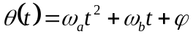. Such signals are called chirps because they sound like the chirp of a bird.

- For 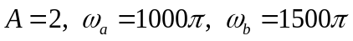 and 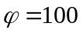, express 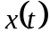 in the sinusoidal form.
- Plot the instantaneous frequency versus time for the period 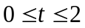.

Solution.

- Instantaneous frequency, 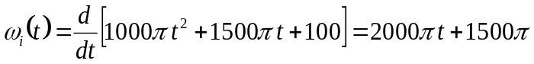 radians/sec.

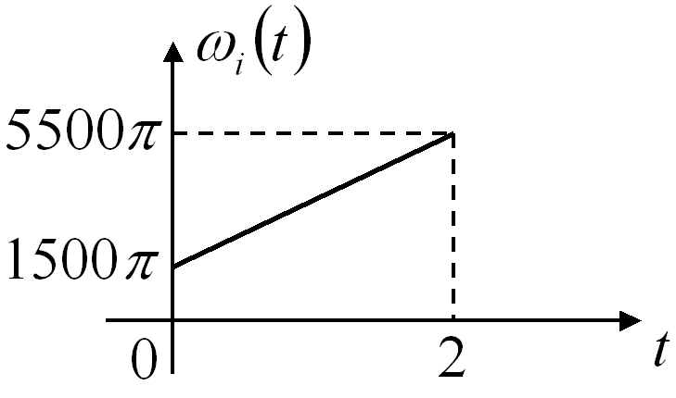

P6. An angle-modulated signal is given by 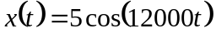 for 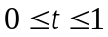. Let the carrier frequency be 10000 rad/(s.volts).

- If is a FM signal with 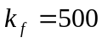, determine the modulating signal 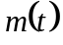 over .
- If is a PM signal with 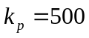 radians/volt, over .

Solution.
- The general expression for an FM signal is 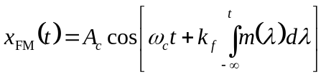. We compare this with the given signal . With 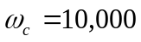 rad/s and we have 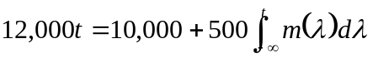 and, therefore, 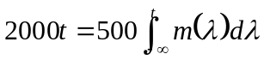. Hence 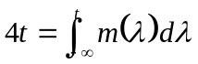 and differentiating both sides w.r.t. yields 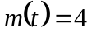.

- The general expression for a PM signal is 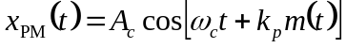. Comparing this with for , we get 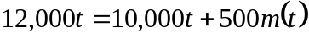 and therefore 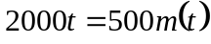. Hence .

